Privacy-Preserving Technique
Role-Based Data Redaction + T-Closeness on HR Dataset
In the contemporary organizations, the employee data entails extremely sensitive personal and professional information. Such data may be illegally exposed, which may result in discrimination, direct attacks and severe violation of privacy. To mitigate this, I created and applied a privacy-aware system on an HR dataset with Role-Based Data Redaction and T-Closeness which were two different methods as compared to my previous applications.
The data consisted of ten recordings of employees, having the following attributes: Employee ID, Full Name, Phone, Department, Experience, Salary and Performance Rating. With Python, Pandas, and NumPy, the implementation was conducted in a Jupyter Notebook, in four major steps.
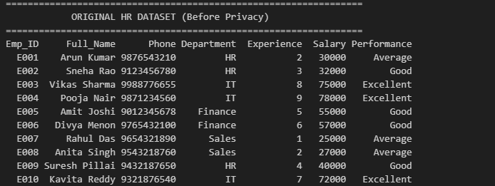
During stage one, I used role-based redaction, which entails replacing the full name values with [REDACTED], anonymizing the Employee IDs with generic codes (EMP_100 to EMP_109), and masking some parts of the phone numbers (e.g., 9876543210 instead of their real values). This will avoid direct identification of a person.
During the second step, I did the experience generalization whereby I transformed precise years into career level bins: Junior (03 yrs) 4-7 years and Senior (8+ years). Salary range masking was used in the third stage with actual values being converted into ₹10,000-range brackets (e.g., ₹30,000- ₹30000- 39999), which does not allow financial inference.
The fourth step involved a T-Closeness check which is the most sophisticated privacy measure that is applicable to each of the three files. It confirmed that the distribution of the sensitive attribute (Performance Rating) in each Department group was much similar to the entire dataset distribution with a significance of t = 0.4. This stops the attack of attribute disclosure attacks, an attacker can deduce the performance of a person based on the knowledge of his department.
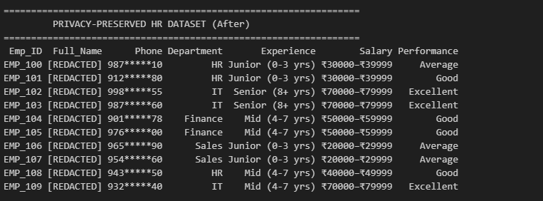
The last privacy-preserved dataset was stored as privacy-preserved-v3.csv which shows a complete and realistic HR data protection pipeline.

